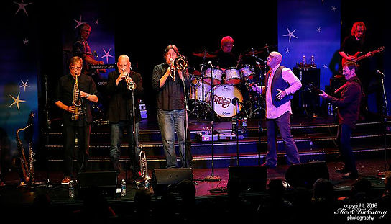

FOR IMMEDIATE RELEASE
(Month Day, Year)

TRANSIT AUTHORITY PERFORMING AT (NAME OF LOCATION)!

Now it is time to watch Transit Authority perform at (Name of Venue), located at (Address of Venue), on (Month Day, Year)!

Transit Authority is the nation's premier tribute band to the historic music of Chicago. This eight-piece power house band consists of some of the most talented musicians in the Midwest. Every show presented by this group of seasoned professionals is a high energy, spot-on tribute to some of the greatest music of all time.

Taking you through over three decades of music and countless hits, Transit Authority provides a non-stop show that will keep you dancing and singing all night long.

For more information, please contact:
(First and Last Name of Contact)
(Name of Contact Company)
(Contact Phone)
(Contact Email)

###

