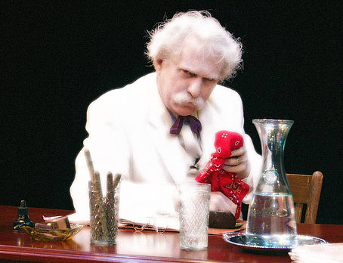

FOR IMMEDIATE RELEASE
(Month Day, Year)

DON’T MISS “RON JEWELL IN MARK TWAIN AT-LARGE” PERFORMANCE AT (NAME OF LOCATION)!

Now it is time to watch Ron Jewell in Mark Twain At-Large performed at (Name of Venue), located at (Address of Venue), on (Month Day, Year)!

Having grown up along the Mississippi River himself, Ron Jewell first donned a white suit in the spring of 1974 to try on the likeness of America’s greatest humorist, Samuel Clemens. Today numerous groups call upon Jewell as the “Missouri Wit” for a variety of convention appearances and theatrical presentations.
​
“Mark Twain At-Large” is Jewell’s full-length one-man theatrical tour de force. Racing in from the thunderous rains, Clemens (a.k.a Twain) invites the audience, his imaginary captured guests, into his private study for an intimate face to face conversation filled with stories and anecdotes taken directly from the literary pages. Jewell’s performance is personable and touching, and delivered as if the humorist is telling the tall tales and yarns for the very first time. Then as quickly as they came, the rains stop, his guests are finally given an opportunity to escape, and the charismatic philosopher sends them out into the night. You’ll believe that you’ve actually spent the evening with the real McCoy.

For more information, please contact:
(First and Last Name of Contact)
(Name of Contact Company)
(Contact Phone)
(Contact Email)

###

