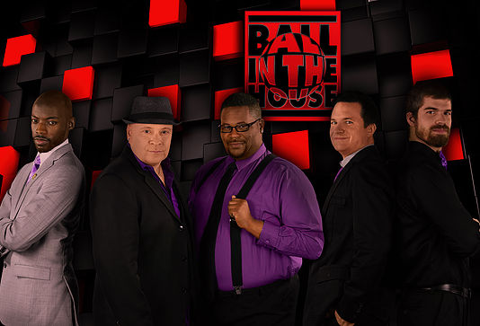
FOR IMMEDIATE RELEASE
(Month Day, Year)

DON’T MISS BALL IN THE HOUSE’S PERFORMANCE AT (NAME OF LOCATION)!

Now it is time to watch Ball in the House perform at (Name of Venue), located at (Address of Venue), on (Month Day, Year)!

Following in the path of classic harmony groups like Boyz II Men, The Temptations, and Take 6, while incorporating the pop and neo-soul influence of artists like Bruno Mars, Daft Punk, and Pharrell Williams, five-member veteran vocal band, Ball in the House, will move audiences and make audiences move.

With their extensive tour schedule (averaging 250 dates a year), Ball in the House reaches millions and is arguably one of the hardest working, most successful indie bands today. Over the years, they have performed with several artists including The Beach Boys, Gladys Knight, Kool & the Gang, KC & The Sunshine Band, Jessica Simpson, and Smokey Robinson.

For more information, please contact:
(First and Last Name of Contact)
(Name of Contact Company)
(Contact Phone)
(Contact Email)

###

