Figuring It Out
Study Guide

We are a family band based in Bemidji, Minnesota. The music we play covers several genres of music from bluegrass to folk, and traditional to contemporary and much more. We hope you enjoy our music and we look forward to connection with you through music and education.

Stringed Instruments
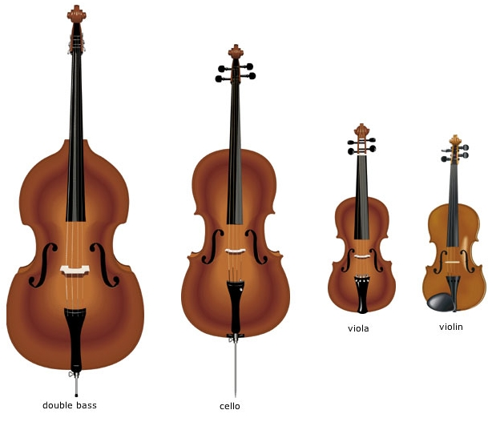

Banjo
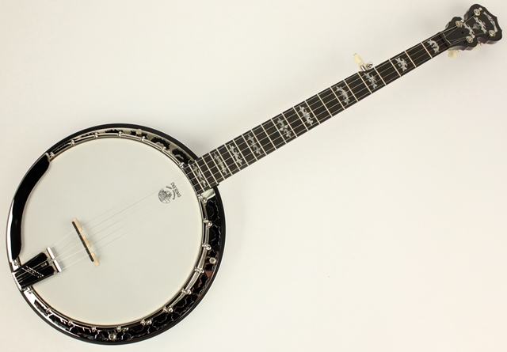

Guitar
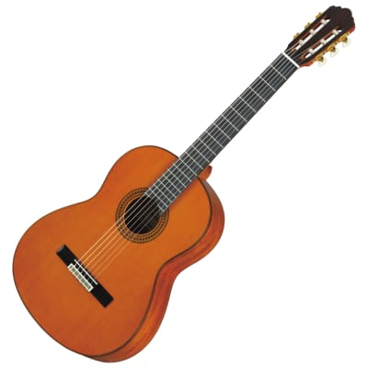

Mandolin
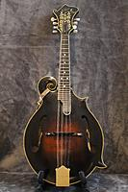

Ukulele
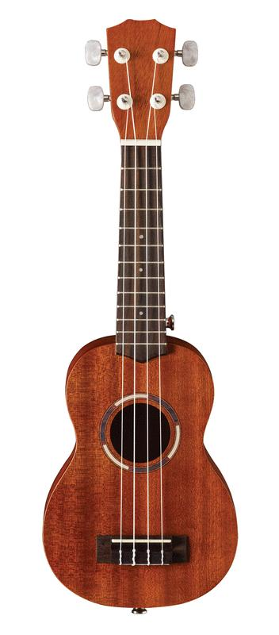
Watch for each of these instruments during the performance. You will find that some are high pitched and others are lower pitched. Can you guess which instruments will have low pitches/sounds?

What are some of the similarities between these instruments?______________________

______________________________________

Which instrument do you like best?

______________________________________

What is bluegrass music? This style of music was established in America in the 1930s by a band called Bill Monroe and the Blue Grass Boys. This is where the term “bluegrass” came from. The music is a mixture of music from immigrants that came to America in the 1600s from Ireland, Scotland and England. Many of the songs were stories about day-to-day life.

Other styles of music you will hear from Figuring It Out band include traditional folk music and Irish music. These styles are similar to bluegrass and the style was brought to America from Ireland, Scotland and England. Like bluegrass, the traditional folk songs originated from storytelling.

Listen to the sounds of the different musical styles/genres. Which do you like best?

_____________________________________
Did you hear stories in the lyrics?

_____________________________________
Which instruments do you feel were featured the most in the bluegrass songs?__________
_____________________________________

Try to write a sentence or two that would be your own story made into a folk or bluegrass song.

_____________________________________

_____________________________________

_____________________________________

_____________________________________

What is your favorite instrument you heard
today? _____________________________

Why do you like this instrument the best?

___________________________________

___________________________________

___________________________________

___________________________________

Map of countries where the sounds for bluegrass and traditional folk music originated.

