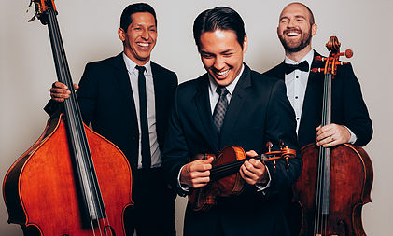
FOR IMMEDIATE RELEASE
(Month Day, Year)

SIMPLY THREE PERFORMING AT (NAME OF LOCATION)!

Now is the time to watch Simply Three perform at (Name of Venue), located at (Address of Venue), on (Month Day, Year)!

Hailed by the Boston Philharmonic, “They’ve got what it takes” says it all for this new and invigorating string trio. Comprised of violinist Glen McDaniel, cellist Zack Clark, and bassist Nicholas Villalobos, Simply Three is redefining string music. Each musician has won numerous awards, trained with world-renowned artists, and performed with symphonies across the nation.

Simply Three is dedicated to enhancing the classical music experience and educating the next generation of musicians. Their commitment to education and fresh approach to fusing pop and classical music have inspired thousands of young audiences across the nation.

For more information, please contact:
(First and Last Name of Contact)
(Name of Contact Company)
(Contact Phone)
(Contact Email)

###

