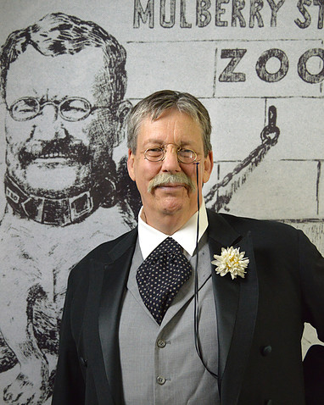
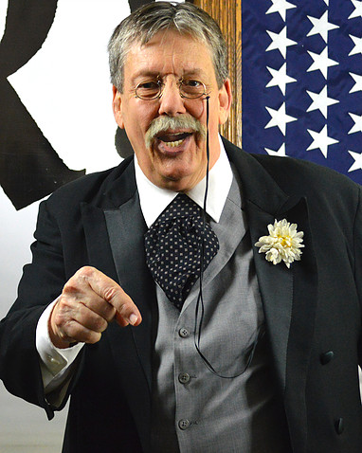
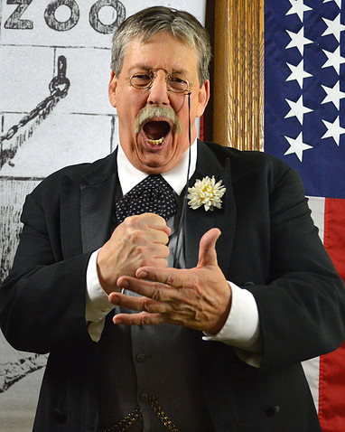
FOR IMMEDIATE RELEASE
(Month Day, Year)

DON’T MISS “MAN IN THE ARENA – TEDDY ROOSEVELT” PERFORMANCE AT (NAME OF LOCATION)!

Now it is time to watch Man in the Arena – Teddy Roosevelt performed at (Name of Venue), located at (Address of Venue), on (Month Day, Year)!

Theodore Roosevelt — “Teddy” to the world — was the face of America for three decades. Powerful, opinionated, intensely loyal, and devoted to the ideal of a just, honorable, and muscular America, he stood for high ideals, and never preached anything he didn’t practice. Roosevelt has been energetically brought back to life by Derek Evans in performances. Come and meet the man Owen Wister called “The most American American who ever lived!”

Come and meet the Bull Moose himself, Teddy Roosevelt! Award winning actor, Derek Evans, brings to life the 26th President of the United States, one of the most exciting and charismatic personalities in all of history. Here’s a show that offers lessons in patriotism, self-reliance, family values, and the conservation of our great natural resources – and everything you ever wanted to know about the Teddy Bear!

For more information, please contact:
(First and Last Name of Contact)
(Name of Contact Company)
(Contact Phone)
(Contact Email)

###

