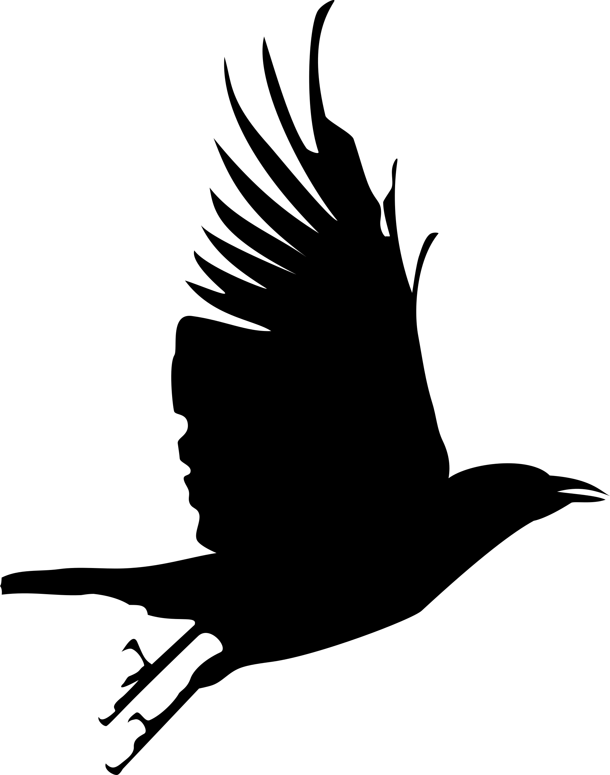**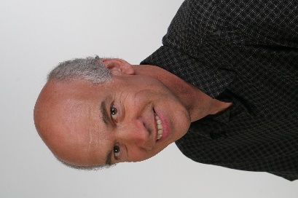Michael Cooper’s Masked Marvels**

**High School Show**

Michael's 45 min high school assembly show is a combination of physical humor, handcrafted masks, and original stories especially designed to engage older students.

Although Michael reserves the right to make changes to his program, this is his basic repertoire:

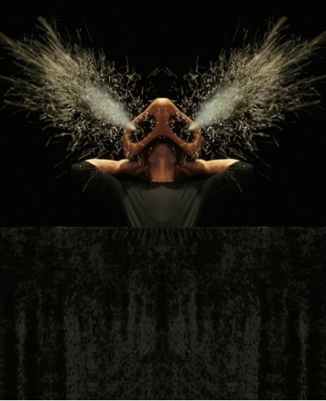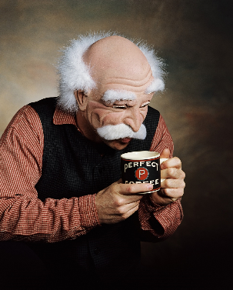

**MAKEOVER** A surreal look at Michael's attempt at self-improvement, using a variety of more and more ridiculous interchangeable facial features, ending in a large and "explosive" finale.

**THE BABY** It's impossible not to be charmed by this wide eyed youngster, and by his amazing transformation into a babysitting grandpa.

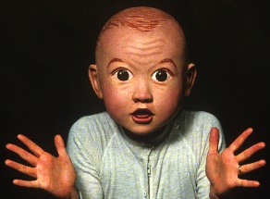

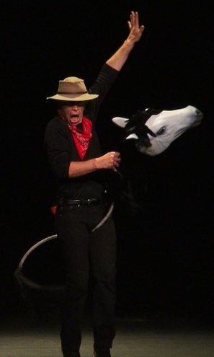

**WILD HORSES** A slow-motion, musical rendition of Michael’s real life veterinarian father breaking his first wild horse.

### **FACE YOUR FEARS**

### A washed up matador sets up a sidewalk booth from which he and his “bullish buddy" offer unsuspecting passers-by “hoofs on” experience in confidence building.

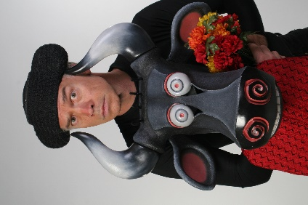

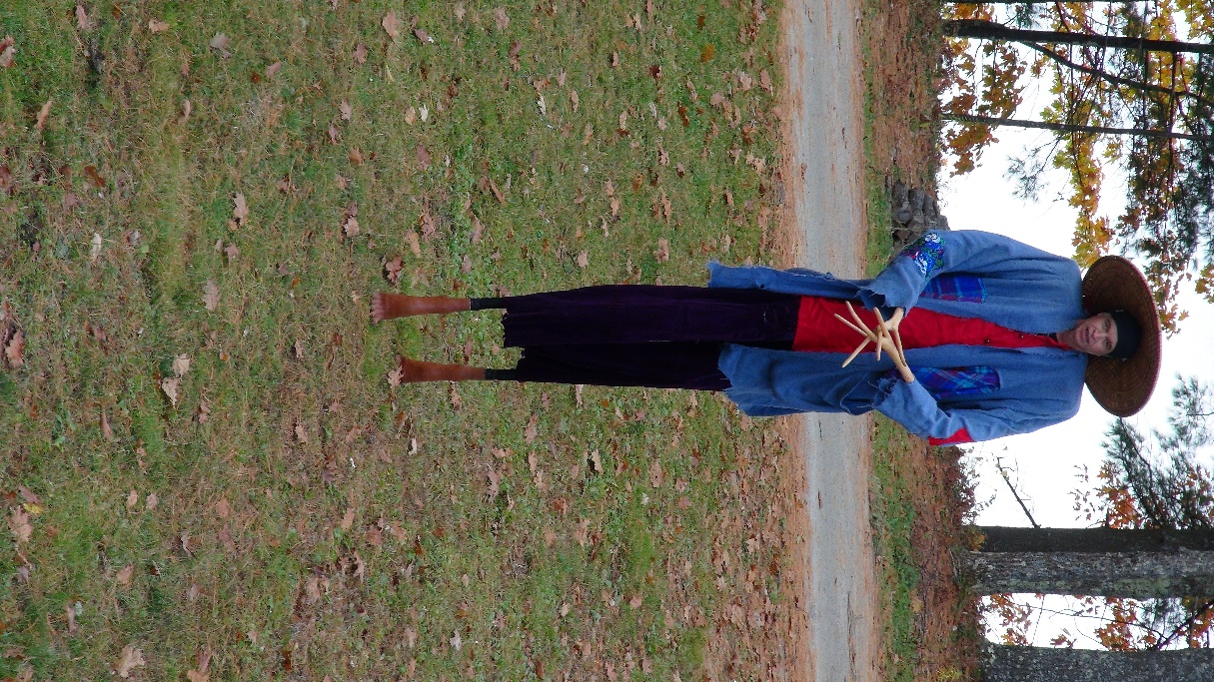

**THE WANDERING SCARECROW** Michael’s spectacular show ender in which a ten foot stilted scarecrow and a couple of wily crows tells tales they have gathered from a life on the open road.

